PA 5431/HRIR 5655: Public Policies on Work and Pay

Fall 2020

**Homework 5 Hint**

Before answering the questions, calculate the following:

1. Cumulative Earnings

2. Percentage of Individuals

3. Cumulative % of Individuals

4. Percentage of Income

5. Cumulative % of Income

1. Calculate the relative interquartile range

Use the following equation to find the relative interquartile range:

2. Graph the Lorenz Curve

To graph the Lorenz Curve, we need to use the percentage of individuals, percentage of income, cumulative percentage of income, and cumulative percentage of individuals to graph the following:

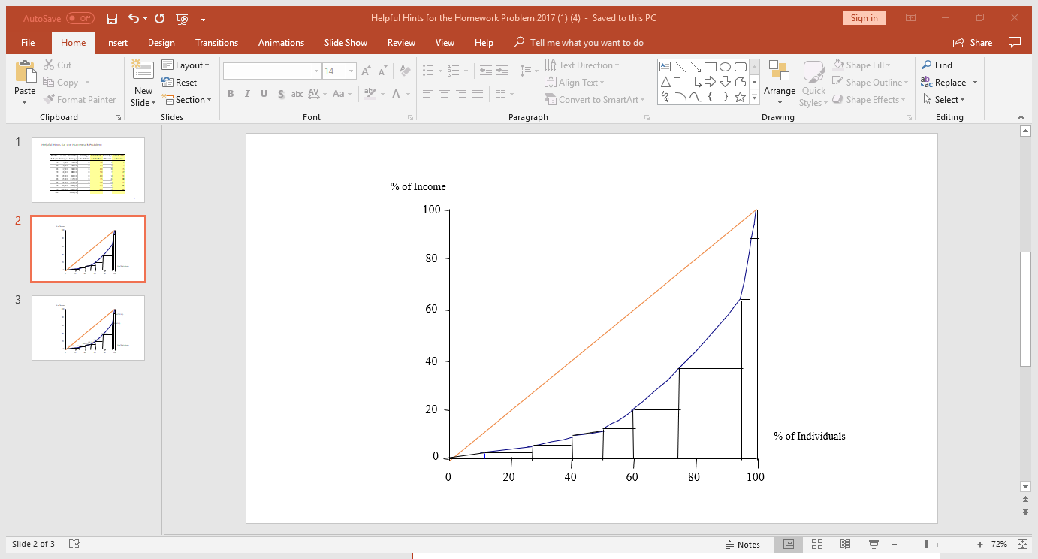

3. Calculate the Gini Coefficient

To calculate the Gini Coefficient, we need to calculate the area under the Lorenz Curve. Then we can use the equation:

$$Gini Coefficient= \frac{0.5*100*100-area under Lorenz Curve}{0.5*100*100}$$